|  |  |
| --- | --- |
| Task 1: Inspecting your VPC |  |
| To connect with amazon cli |  |
| To show vpcs we can use this comand |  |
| DescribeSubnets that connect to vpc  We can use this command | # This command retrieves the details of all subnets associated with the specified VPC ID and displays them in a table format.  aws ec2 describe-subnets --filters "Name=vpc-id,Values=vpc-0cfe31170e4dc9e43" --output table |
| To query the routing tables for VPC ID vpc-0cfe31170e4dc9e43, you can use the following command: | # This command retrieves information about the route tables in the specified VPC, including their IDs and associated subnets.  aws ec2 describe-route-tables --filters "Name=vpc-id,Values=vpc-0cfe31170e4dc9e43" --query 'RouteTables[*].[RouteTableId, VpcId, Associations[*].SubnetId]' |
| To query the Internet Gateways associated with | # This command lists all internet gateways attached to the specified VPC.  aws ec2 describe-internet-gateways --filters "Name=attachment.vpc-id,Values=vpc-0cfe31170e4dc9e43" |
| To view the Network ACLs associated with a VPC: | # This command retrieves and displays the network access control lists (ACLs) for the specified VPC.  aws ec2 describe-network-acls --filters "Name=vpc-id,Values=vpc-  0cfe31170e4dc9e43" --output table |
| To query the Security Groups associated with VPC ID vpc-0cfe31170e4dc9e43, you can use the following command: | aws ec2 describe-security-groups --filters "Name=vpc-id,Values=vpc-0cfe31170e4dc9e43" --query 'SecurityGroups[*].[GroupId, GroupName]' --output table |

|  |  |  |
| --- | --- | --- |
|  |  | Task 2: Creating an Application Load Balancer |
| 1 | Create security group | # This command creates a new security group named 'Inventory-LB' with a description, associated with the specified VPC.  aws ec2 create-security-group --group-name Inventory-LB --description "Enable web access to load balancer" --vpc-id vpc-0cfe31170e4dc9e43 |
| 2 | Inbound Rules | # This command allows inbound HTTP traffic on port 80 for the specified security group.  aws ec2 authorize-security-group-ingress --group-id <SecurityGroupID> --protocol tcp --port 80 --cidr 0.0.0.0/0 |
| 3 | Load  Balancer | # This command creates a new load balancer named 'Inventory-LB' in the specified subnets and security group.  aws elbv2 create-load-balancer --name Inventory-LB --subnets subnet-0cdb0fefee3d033f2 subnet-0acf6d72db17f0373--security-groups sg-01a9fe5c216e7c26a |
|  |  | # This command creates a target group named 'Inventory-App' that will route HTTP traffic to instances in the specified VPC.  aws elbv2 create-target-group --name Inventory-App --protocol HTTP --port 80 --vpc-id vpc-0cfe31170e4dc9e43 |
| 4 | Instance ID |  |
| 5 |  | # This command registers an EC2 instance with the specified ID as a target for the target group.  aws elbv2 register-targets --target-group-arn arn:aws:elasticloadbalancing:us-east-1:667166769231:targetgroup/Inventory-App/d40bcb60cdf1d992 --targets Id=i-0d43795bc7c648c42 |

|  |  |  |
| --- | --- | --- |
| 6 | Listener | # This command creates a listener for the load balancer that forwards HTTP traffic to the specified target group.  aws elbv2 create-listener --load-balancer-arn arn:aws:elasticloadbalancing:us-east-1:667166769231:loadbalancer/app/Inventory-LB/7a181734143605bc --protocol HTTP --port 80 --default-actions Type=forward,TargetGroupArn=arn:aws:elasticloadbalancing:us-east-1:667166769231:targetgroup/Inventory-App/d40bcb60cdf1d992 |

|  |  |  |
| --- | --- | --- |
| 7 |  |  |
|  |  |  |
|  |  |  |

|  |  |  |
| --- | --- | --- |
|  |  | Task 3: Creating an Auto Scaling Group |
| **1** | **Creating an AMI for Auto Scaling** | # This command creates an AMI from the specified EC2 instance.  aws ec2 create-image --instance-id <InstanceID> --name "Web Server AMI" --description "An AMI for my web server" |
|  | Create the Launch Template |  |

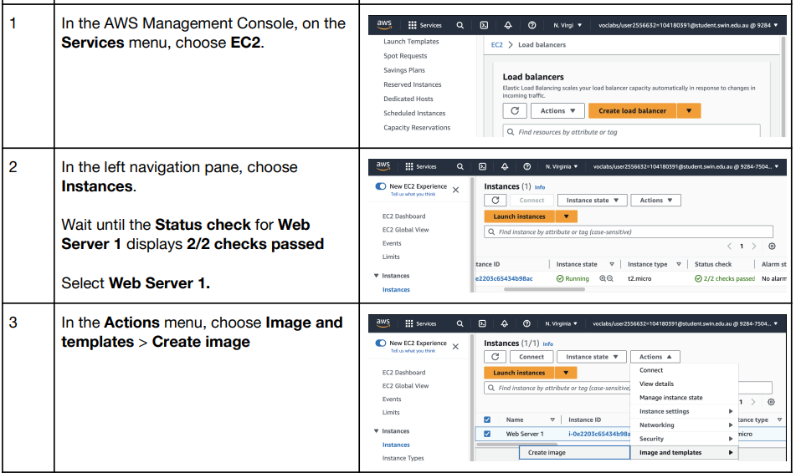

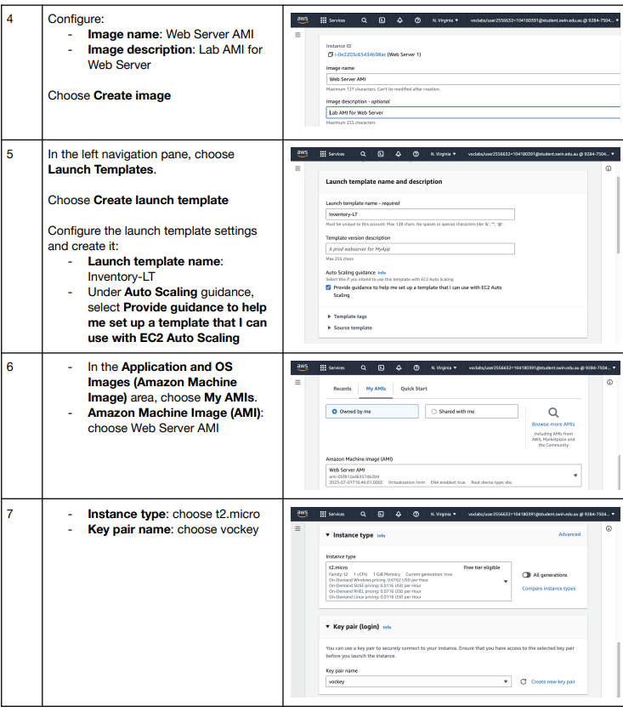

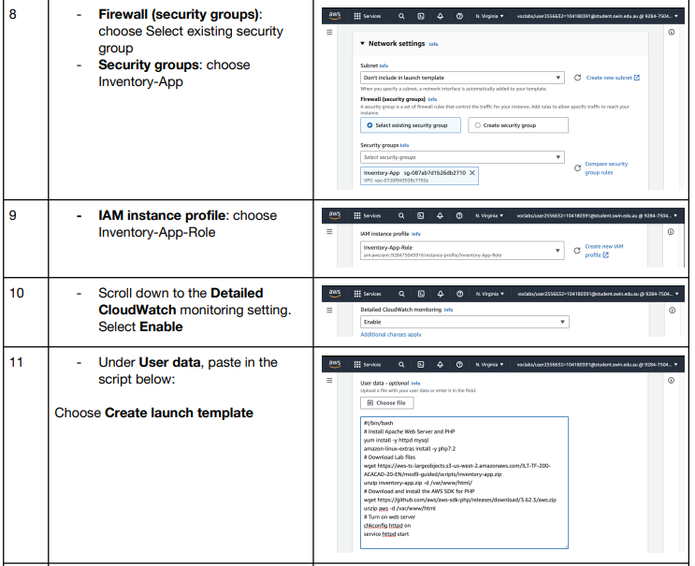

|  |  |  |  |
| --- | --- | --- | --- |
|  | **Create Auto Scaling Group**: | | # This command creates an auto-scaling group named 'Inventory-ASG' with specified minimum, maximum, and desired capacity.  aws autoscaling create-auto-scaling-group --auto-scaling-group-name Inventory-ASG --launch-template "LaunchTemplateName=Inventory-LT" --min-size 2 --max-size 2 --desired-capacity 2 --vpc-zone-identifier "subnet-0cdb0fefee3d033f2,subnet-  0acf6d72db17f0373" |
|  | Authorize Security Group Ingress for HTTP: | | aws ec2 authorize-security-group-ingress --group-id sg-01a9fe5c216e7c26a --protocol tcp --port 80 --source-group sg-011d82d0b7e24eec1 |
|  | Authorize Security Group Ingress for MySQL | | aws ec2 authorize-security-group-ingress --group-id sg-0d7f6595adc65d823 --protocol tcp --port 3306 --source-group sg-011d82d0b7e24eec1 |
|  | Describe Load Balancers | | aws elbv2 describe-load-balancers --names Inventory-LB --query 'LoadBalancers[*].DNSName' |
|  | Terminate EC2 Instances | | \  aws ec2 terminate-instances --instance-ids i-0d43795bc7c648c42 |
|  | |  |  |
|  | | Describe Instancs | aws ec2 describe-instances --query 'Reservations[*].Instances[*].[InstanceId, InstanceType, State.Name, PublicIpAddress]' |
|  | | Describe Target Health: | aws elbv2 describe-target-health --target-group-arn arn:aws:elasticloadbalancing:us-east-1:667166769231:targetgroup/Inventory-App/d40bcb60cdf1d992 |
|  | | Modify RDS DB Instance for Multi-AZ: | # This command modifies the RDS instance to enable Multi-AZ deployment immediately.  aws rds modify-db-instance --db-instance-identifier inventory-db --multi-az --apply-immediately |
|  | | **Elastic IP**: | aws ec2 describe-addresses --query 'Addresses[*].{AllocationId:AllocationId,PublicIp:PublicIp}' --output table |
|  | | **NAT gateway** | # This command creates a NAT gateway in the specified subnet with the specified Elastic IP allocation ID.  ws ec2 create-nat-gateway --subnet-id subnet-0acf6d72db17f0373 --allocation-id eipalloc-02b04329ca7b87e24 --tag-specifications 'ResourceType=natgateway,Tags=[{Key=Name,Value=NatGateway2}]' |
|  | | Allocate an Elastic IP: | aws ec2 allocate-address --domain vpc |
|  | | **Create route table** | aws ec2 create-route-table --vpc-id vpc-0cfe31170e4dc9e43 --tag-specifications 'ResourceType=route-table,Tags=[{Key=Name,Value=Private Route Table 2}]' |
|  | | إضافة مسار لـ NAT Gateway: | aws ec2 create-route --route-table-id rtb-0c407d5ed58cdf0de --destination-cidr-block 0.0.0.0/0 --nat-gateway-id nat-0330098585c3d9abc |
|  | | associate a specified route table | aws ec2 associate-route-table --subnet-id subnet-0cb898553f52a6700 --route-table-id rtb-0c407d5ed58cdf0de |
|  | |  |  |
|  | |  |  |